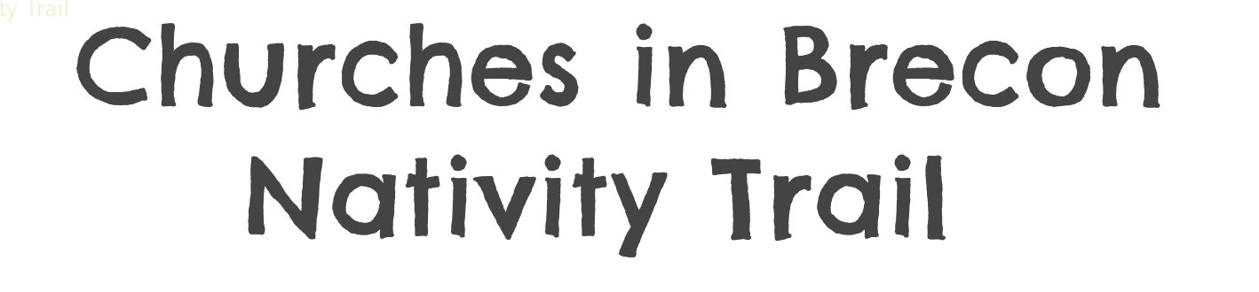
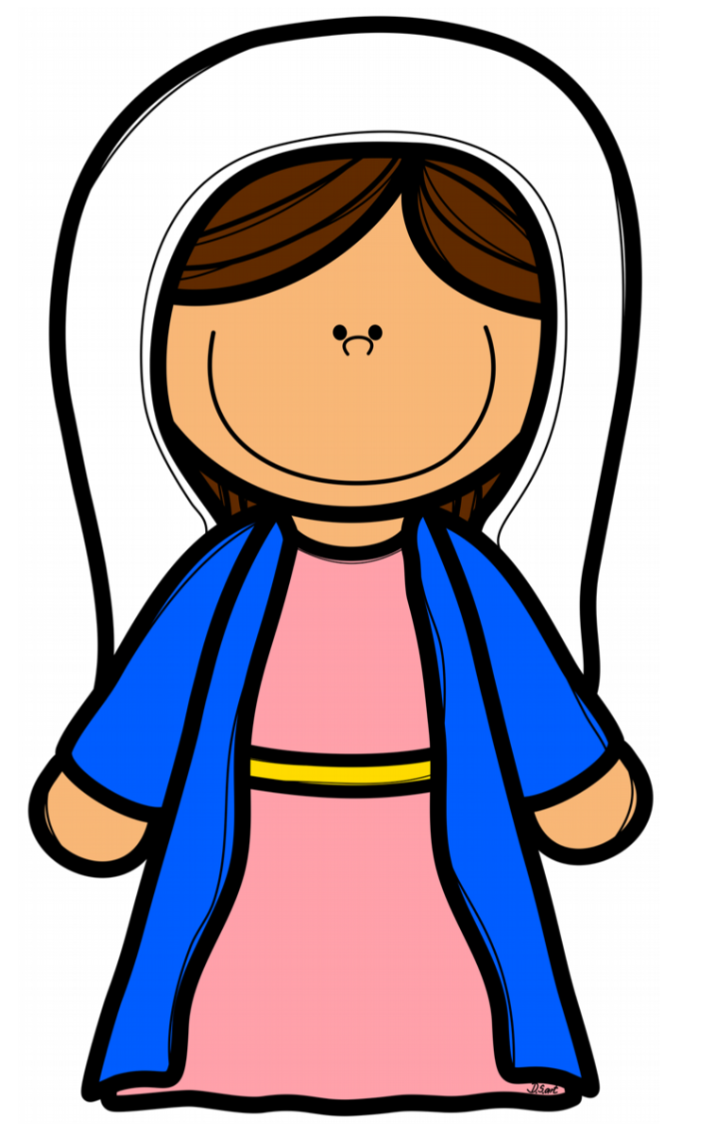
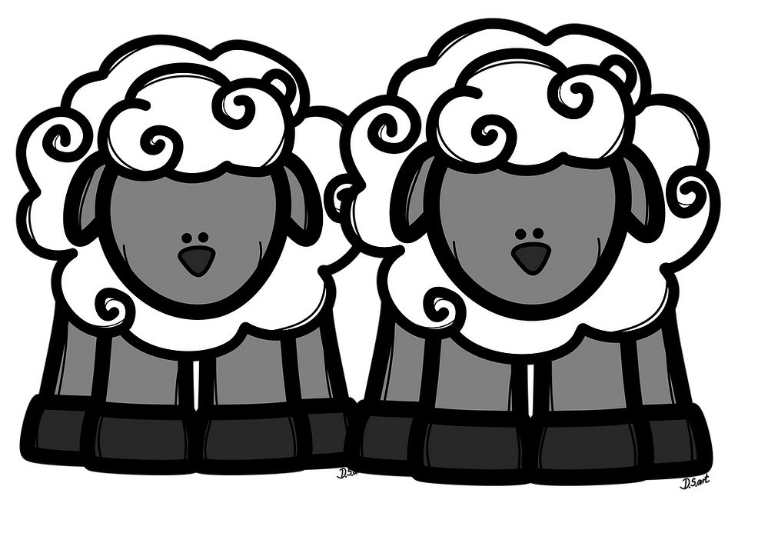
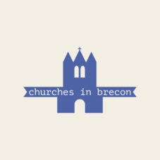
Hidden around Brecon are 19 characters from the Nativity!
They are hidden in local shop and business windows.
Each character has a QR code, click on the code and find out how that character fits into the story. You will also find a fun and easy craft to do at home. Complete this form, finding all 19 characters and win a prize!
Name: _______________________________
Contact number or email address: _______________________________
 | Name of Character | Whose window was I in?
1
2
3
4
5
6
7
8
9
10
11
12
13
14
15
16
17
18
19

To claim your prize, please return this form to Rev Emma Franks, Kensington Baptist Church, Brecon LD3 3DAY or send it via email to kbcbrecon@gmail.com or take a screen shot and send via Whatsapp to 07739 722842.
We would also love to see photos when you find any of them - add them to Kensington Baptist Church Facebook page and we can share them with Churches in Brecon.
We are very grateful to all our shops and businesses for being willing to be involved in this bit of Festive fun. We are so blessed with such a wonderful community here in Brecon.

Happy Christmas to you all!

